AFFIDAVIT UNDER SECTION 255 TAX LAW

STATE OF NEW YORK | :
 | :ss.:
COUNTY OF WESTCHESTER | :

_____________________________, being duly sworn, disposed and says:

1. That he/ she is the owner and holder of the hereinafter described mortgage, and is familiar with the facts and circumstances set forth herein.

- That an instrument herewith offered for recording is identified as follows:

(a). | Type of Instrument:
(b). | Date of Instrument:
(c). | Parties:
 |  | Mortgagor:
 |  | Mortgagee:
(d). | Amount of Loan:
(e). | Mortgage Tax to be paid

- That the mortgage to which the above instrument is supplemental is identified as follows:

(a). | Dated:
(b). | Parties:
 |  | Mortgagor:
 |  | Mortgagee:
(c). | County of Recording:
(d). | Date of Recording:
(e). | Liber and Page:
(f). | Mortgage Tax Paid:
(g). | Present Mortgage Balance:
(h). | Original Mortgage Amount:

- That the ___________________________________contained in this mortgage does not secure a
re-loan or re-advance or new loan except the indebtedness secured by the previously recorded mortgage set out in paragraph three (3) above.

- That the exception from further tax is claimed under Section 255 of the Tax Law as to the said instrument herewith offered for recording.

- That the maximum amount secured hereunder and in conjunction with the previously recorded mortgage is:

________________________________


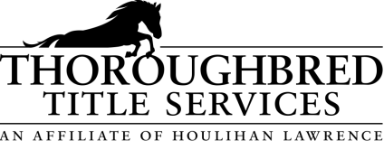
DISTRIBUTED BY

800 Westchester Avenue Suite S434, Rye Brook, NY 10573
Phone: (914) 644-6100 Fax: (914) 644-6159
www.thoroughbredtitleservices.com
DISTRIBUTED BY

800 Westchester Avenue Suite S434, Rye Brook, NY 10573
Phone: (914) 644-6100 Fax: (914) 644-6159
www.thoroughbredtitleservices.com
Sworn to before me this
day of , 20

____________________________
Notary Public

