AFFIDAVIT OF EXEMPTION
SECTION 253 (1-a)

STATE OF NEW YORK | :
 | :ss.:
COUNTY OF WESTCHESTER | :

_____________________________, being duly sworn, disposed and says:

The undersigned is the (Attorney for the) owner and holder of the hereinafter described mortgage, and is fully familiar with the fact set forth herein.

That the mortgage offered for recording dated _____day of ___________, 20____ made by:

__________________________________________________________________

to

__________________________________________________________________

That the mortgagee(s) is(are) a natural person or persons and the mortgaged premises consists of real property improved by a structure containing six residential dwelling units or less, each with separate cooking facilities.

WHEREFORE, your deponent respectfully requests that the mortgage
offered for recording herein be exempted from the special additional mortgage recording tax set forth in Section 253 (1-a) of the tax law.

_____________________________

Sworn to before me this __
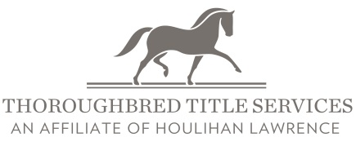
day of , 20
DISTRIBUTED BY

800 Westchester Avenue Suite S434, Rye Brook, NY 10573
Phone: (914) 644-6100 Fax: (914) 644-6159
www.thoroughbredtitleservices.com

____________________________
Notary Public

